Internationally  Recognised  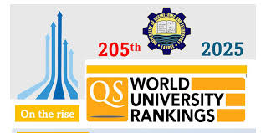  Uet is an internationally recognized university. |  | 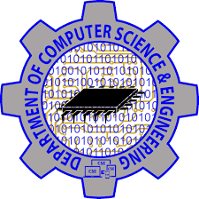  Visit us online  Lms.edu.pk  Cse.uet.edu.pk  Uet.acm@gmail.com | 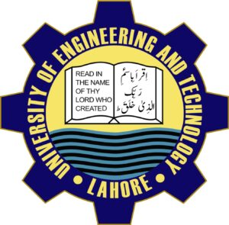Department of Computer Science and Engineering,UET Lahore  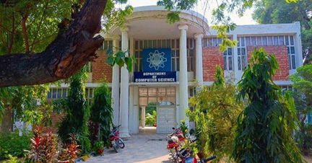

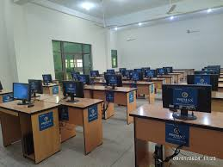  Courses Offered  - Bsc.Computer Engineering  - Bsc.Computer Science  - Msc.Computer Science  - Msc.Computer Engineering  Careers  - Software Development  - Network & computer system Administrator  - ComputerNetwork architect | The science of today is the technology of tomorrow.  -Edward Teller  Huytyy  Technical Society  UET ACM is one of the most celebrated scientific society which is actively participated in different events in coordination with ICOSST (KICS)  - IET UET Society  - Computer Club  - IEEE Society  Computer Facilities  Computer cell is providing all facilities with advance internet facility to whole university. | DEAN: Prof Dr.Sohail Aftab Qureshi  Chairman:Prof Dr.Muhammad Shahbaz  Contact us  Uet admissions 042-99029216  Registrar 042-99029216227  Deputy Registrar 042-9902921609  Assistant Registrar 042-99029216497

